**mCRAFT QC INTEGRATION – SETUP GUIDE**

**mCraft Setup Guide**:

Download the mCRAFT – Selenium QC Integration & import the project into eclipse using the below steps!

1. Open Eclipse & create a new **Java project**

2. Provide a name for Java Project & select **Use project folders as root for sources and class files** option from the Project layout frame & Click **Finish**.

3. Right Click on the project & select **Import** option to import the mCRAFT project into eclipse workspace.

4. In the **Import wizard**, Select **General** -> **File System** option & Click **‘Next’**

5. Browse for mCRAFT, which has been downloaded.

6. After selecting, the folder name will be displayed in the right hand side window, please check the check box against it & Click **Finish**

7. Once after **‘Import’**, you should reference the packages, which would be required for the project to work. You will be able to see errors in the project, which will go off, as you refer the proper files/jars.

8. To refer the jar files, navigate to the properties of the project & select **Java Build Path** -> Libraries option

9. Select ‘**Add External Jars’** option & select the jar files present in **External Jars** Folder under **supportlibaries** package that need to be referenced & Click **OK**. mCRAFT setup is Successful!

11. Now Navigate to RunTest.bat in Eclipse, open in text editor.

12. Edit you RunTest.bat accordingly.

***C -Drive:***

C:

cd "C:\Projects\My Projects\CRAFT ,CRAFTLite\CRAFT_mCRAFTintegration\CRAFT_mCRAFT"

java -cp ".;.\supportlibraries\External_Jars\*" allocator.QcTestRunner %*

***D -Drive:***

D:

cd "D:\Projects\My Projects\CRAFT ,CRAFTLite\CRAFT_mCRAFTintegration\CRAFT_mCRAFT"

java -cp ".;.\supportlibraries\External_Jars\*" allocator.QcTestRunner %*

**QC Setup Guide:**

Note: Create a new User Defined field called Framework path under Test set: where we will mentioning the eclipse craft frameworks path (How to create User Defined field is out of scope in this doc, refer QC admin guide for more details)

1. Open HP QC by providing valid user credentials
2. Click on **Testing Menu** present on Left hand side panel
3. Under Testing menu click on **Test Plan**
4. Create a Folder under root folder under **Subject**. For better readability you can name as Eclipse Project Name example : **mCRAFT**
5. Now create a sub-folder under mCRAFT folder and make sure the name of the

Sub-folder is referred to TestScenario in (Run Manager.xls) e.g. Name it as “Scanerio1”, “MobileTestingScenario” etc.

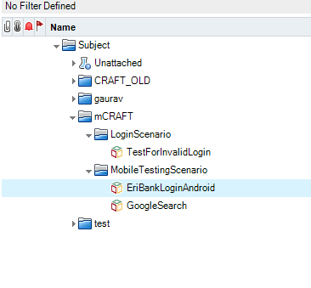

***Test Plan Module HP ALM***

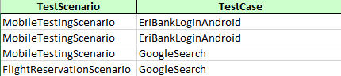

***Run Manager.xls***

1. Create a New VAPI – XP - Test , click on Next, Next and finish to create the script, name it as same name referred as “Test Case “ in (Run Manager.xls) mCRAFT framework and newly created VAPI – XP Test should be present under “Scenario1”/ “MobileTestingScenario” subfolder
2. Navigate to Eclipse (mCRAFT) project and look up for package called “Miscellaneous” and copy paste the content of “VAPI-XP Script.vbs” and paste it under same test case created in above step in TestScript Tab

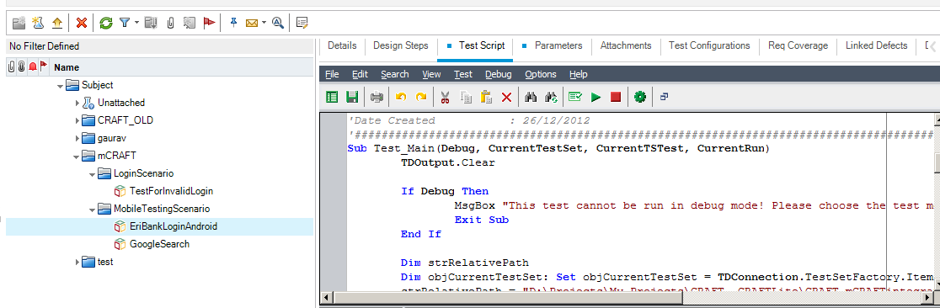

1. Now create a new set of parameters as mentioned below under Parameters Tab present in VAPI-XP Test “TC1 “, make sure the order is as below

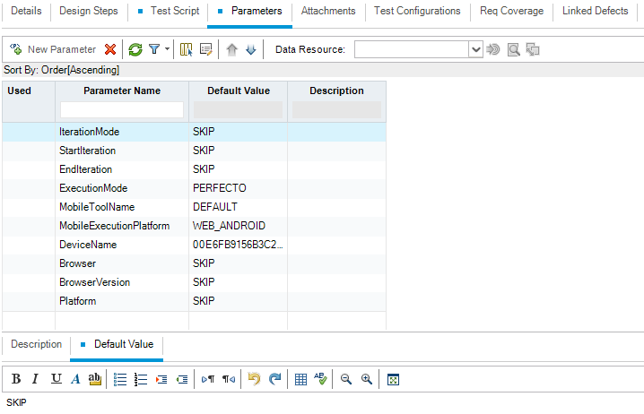

|  |  |  |
| --- | --- | --- |
| ***Parameter Name*** | ***Valid Values (sample values)*** | ***(Default value)*** |
| **IterationMode** | |  | | --- | | RUN_ALL_ITERATIONS | | RUN_ONE_ITERATION_ONLY | | RUN_RANGE_OF_ITERATIONS | | SKIP |
| **StartIteration** | 1 | SKIP |
| **EndIteration** | 1 | SKIP |
| **ExecutionMode** | |  | | --- | | LOCAL | | REMOTE | | LOCAL_EMULATED_DEVICE | | REMOTE_EMULATED_DEVICE | | GRID | | PERFECTO | | MOBILE | | SEETEST | | MOBILELABS | | SKIP |
| **MobileToolName** | |  | | --- | | DEFAULT | | APPIUM | | REMOTE_WEBDRIVER | |  |
| **MobileExecutionPlatform** | |  | | --- | | ANDROID | | IOS | | WEB_ANDROID | | WEB_IOS | |  |
| **DeviceName** |  | SKIP |
| **Browser** | |  | | --- | | CHROME | | FIREFOX | | GHOST_DRIVER | | HTML_UNIT | | INTERNET_EXPLORER | | OPERA | | SAFARI | | SKIP |
| **BrowserVersion** | 13.0 | SKIP |
| **Platform** | WINDOWS | SKIP |

Here if Default Value “SKIP” means, it would take up all default values as per mCRAFT Framework, it will refer Global Setting.Properties and Mobile Automation Setting.Properties

1. Traverse to **Test Lab** Menu and create a New Folder should be present under **Root** Folder. For better readability you can name as Eclipse Project Name example : mCRAFT
2. Now create a new **Test Set** and make sure the name of the Test Set should be referred to Run Configuration value present in Global settings. properties file CRAFT Framework for example : Test Set Name : **Regression**
3. Provide your mCraft Framework Eclipse workspace path into Framework Path field present in Test Set
4. Or Please provide the Eclipse project path under VAPI XP test script,

strRelativePath = "D:\Projects\My Projects\CRAFT ,CRAFTLite\CRAFT_mCRAFTintegration\CRAFT_mCRAFT" 'Customize this line as required

1. Now move on to **Execution Grid Tab** in **Test Set** and try importing “TC1” Test by selecting Select Test button
2. After importing Click on Run button present at the top of Execution Grid menu Tab
3. Click on **Run Tests Locally**
4. You can able to view Automatic Runner and click on Run or Run All and you can able to view execution window opening up which will invoke QcDriverScript.vbs present under supportlibaries package in mCRAFT framework
5. Now you can able to view the execution over browser/device instance
6. After the execution “Test Status” will be updated in status field present in Execution Grid Tab
7. Results will be attached for each **Test Run** : Double click on Test instance and you can able to view Test Instance in detail and navigate to Attachments Tab you can view CRAFT Framework results attached to it

**Execution in Test Plan:**

1. Please Navigate to Test Plan, go the respective VAPIXI Script (ex: TC1), click on Test Script Tab.
2. Now click on Test in Menu Bar, click on Execute [Test Mode].

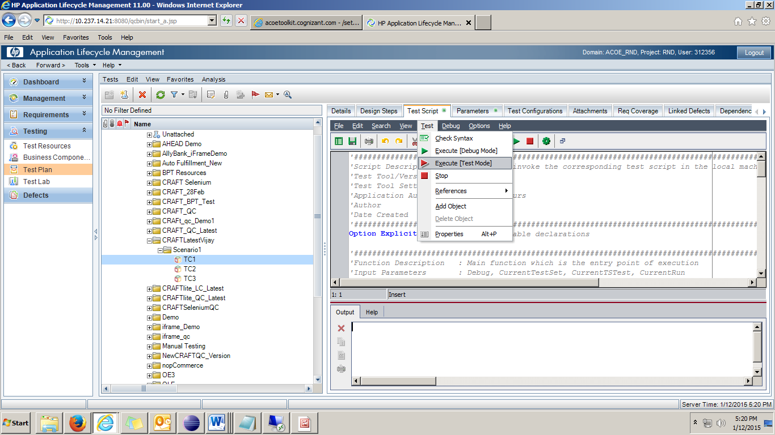

1. Select the appropriate Test Set from Test Lab as below and click on OK.( Make sure that before you execute the Test Script should be mapped in any of Test Set in Test Lab)

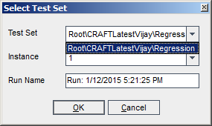

1. Now the execution starts. If it fails, please check the error from Output Memo field.

